Name-Aditi Sudhir Igade

Div-A Roll no-221081

PRN. No-22220311

Assignment –3

**PROBLEM STATEMENT:**

Derive a subclass called Student from the superclass Computer_Engg. The clasastudent inherits all the member variables(Name,Roll_Number,GR_Number,hobbies,etc) and methods (getGR(), getName(), among others) from its superclass Computer_Engg, also further defines a variable called area_of_interest,marks & two public methods getmarks() and getarea_of_interest().

**OBJECTIVE: -**

To understand concepts of inheritance by writing a program for creating superclass Computer_Engg and subclass Student applying

## THEORY:-

**Inheritance in Java** is a mechanism in which one object acquires all the properties and behaviours of a parent object. It is an important part of OOPS (Object Oriented programming system).The idea behind inheritance in Java is that you can create new classes that are built upon existing classes. When you inherit from an existing class, you can reuse methods and fields of the parent class. Moreover, you can add new methods and fields in your current class also. Inheritance represents the **IS-A relationship** which is also known as a *parent-child* relationship.

**ALGORITHM:-**

1. Create Parent Class Computer_Engg.
2. Declare variables Name,Roll_Number,GR_Number,hobbies using appropriate data type.
3. Write the functions getGR() and getName() in parent class
4. Derive the Student class from parent class using extends keyword.
5. Declare variables area_of_interest, marks using appropriate data type in student class.
6. Write the any tow public functions like getMarks(), getArea_of_intrest() in student class
7. Display all student information using the functions and variables used in parent as well child class.

**Code-**

import java.util.Scanner;

class Comp_Stud{

static public String name;

public String hob;

public int roll;

public int gr;

void get(int n){

roll=n;

}

void get1(String s){

name=s;

}

void display(){

System.out.println("Name of student is="+name);

System.out.println("The Roll no. of Student="+roll);

}

}

class Student extends Comp_Stud{

String interest;

public int marks;

void get_area_of_interest(String s1){

interest=s1;

}

void getMarks(int n1){

marks=n1;

}

void getGr(int g){

gr=g;

}

void display(){

super.display();

System.out.println("Entered gr no is ="+gr);

System.out.println("The marks entered are="+marks);

System.out.println("The hobbies od student is="+interest);

}

}

public class Main

{

public static void main(String[] args) {

Scanner sc=new Scanner(System.in);

System.out.println("Enter the Name of Student");

String s2=sc.next();

System.out.println("Enter the roll no of student");

int a=sc.nextInt();

System.out.println("Enter the hobbies of student");

String f=sc.next();

System.out.println("Enter the marks of student");

int m=sc.nextInt();

System.out.println("Enter the gr no. of student");

int h=sc.nextInt();

Comp_Stud obj=new Comp_Stud();

Student obj1=new Student();

obj1.get(a);

obj1.get1(s2);

obj1.get_area_of_interest(f);

obj1.getGr(h);

obj1.getMarks(m);

obj1.display();

}

}

**Output-**

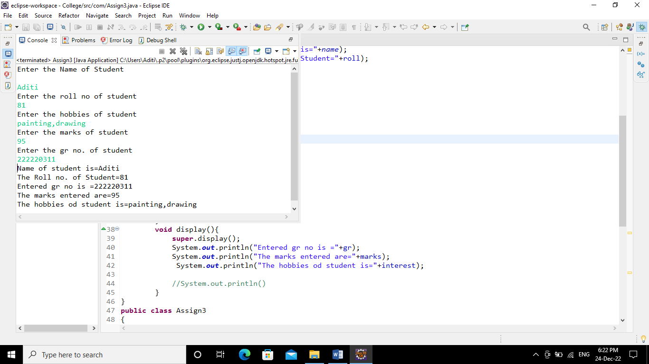

**Conclusion**- Able to understand and apply the object oriented concept of inheritance.